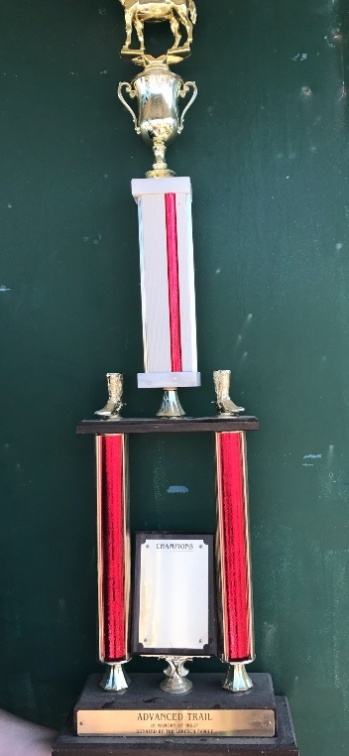
Advanced Trail Rotating trophy
In Memory of: “Milo”
Awarded to the Winner of the advanced trail class at the Lake County Fair
In Loving Memory of “Milo”
Established: 2014
Donated by: The LaRush Family
Retire to the LaRush family in 10 years (2024)

Novice Trail Rotating Trophy
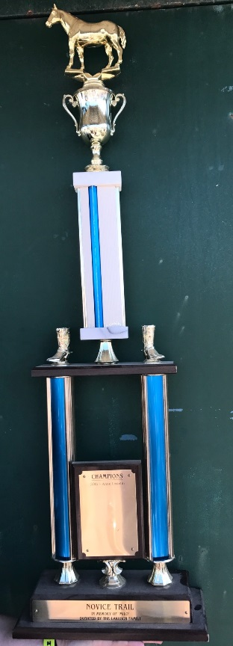
Awarded to the Novice Trail Class winner at the Lake County Fair
In loving Memory of “Milo”
Established: 2014
Donated by: The LaRush Family
Retire to the LaRush Family in 10 years (2024)

Aruta Family Rotating Trophy

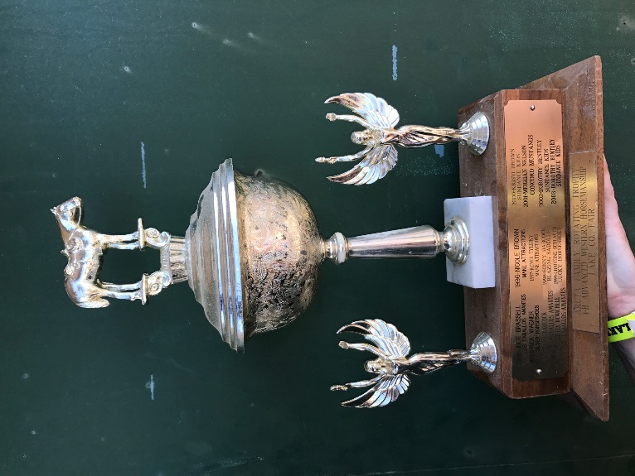
In Memory of The Aruta family and all their hard work and dedication to 4-h.
Donated by: Lucky Horse Shoes 4-h Club
Awarded to the Advanced Western Horsemanship winner at The Lake County Fair
Established: ____________
Retire: Never to retire- when the trophy runs out of room it will be put in the Historical building and a new one will be donated

Contesting Versatility Rotating Trophy

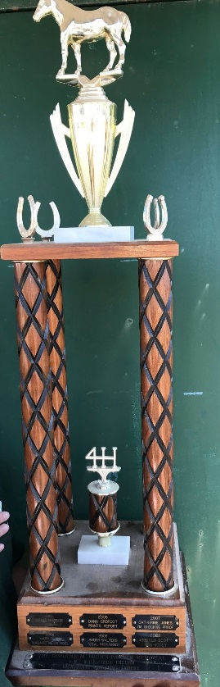
Awarded to the winner of the Advanced Contesting Versatility at the Lake County Fair
Donated by: Steering committee
Established_________
Retire: Does not retire- when there is no longer any space the trophy will go to the Historical Building at the Lake County Fair Grounds. A new one will be donated.

Advanced Performance Versatility
Rotating “Ma Maurer” Trophy
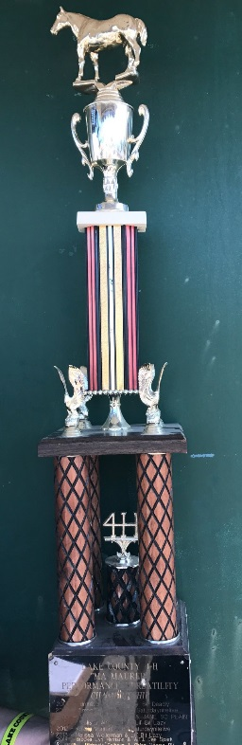
Donated by: Ma Maurer
Awarded to the winner of the Advanced Performance Versatility at the Lake County Fair
Established:__________
Retire: Does not retire; when there is no more space the trophy goes to the Historical Building at the Lake County Fair Grounds and another trophy will be donated.

“Charlie the Pony” Rotating Trophy
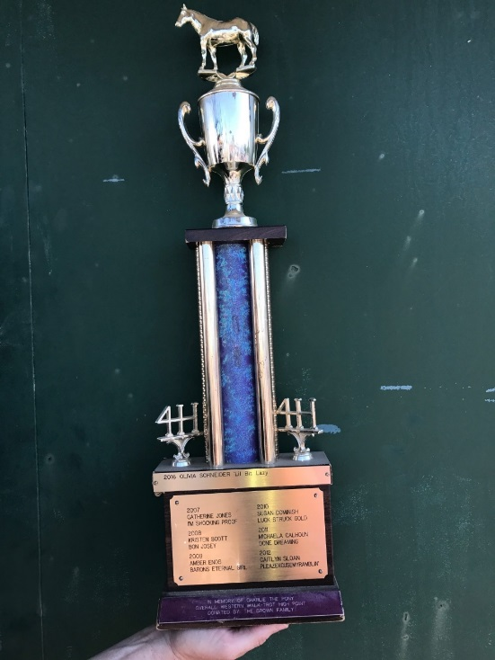

Awarded to the Walk/Trot Western High Point at the Lake County Fair
In loving Memory of “Charlie the Pony”
Established: 2000
Donated by the Brown Family
Retire: 20 years to the Brown Family (2020)

Walk/Trot Contesting Rotating Trophy

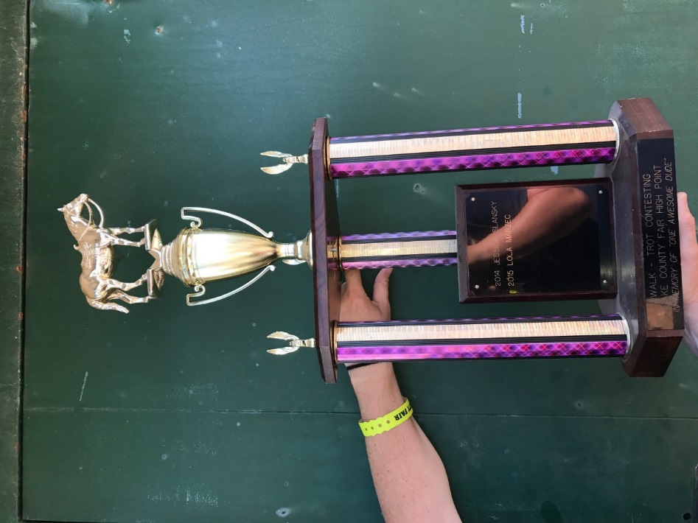
Awarded to walk/trot contesting high point at the Lake County Fair
In Memory of “One Awesome Dude”
Established 2013
Donated by the Salanksy Family
Retire: 10 years to Jessica Salansky (2023)

Walk/Trot Western/English High Point Trophy

Awarded to the walk/trot rider with the highest points in both English and Western Classes
Donated by: Tummy Acres Farm; Jerry, Carol and Renee
Established: 2013
Retire to Tummy Acres Farm in 20 years (2033)
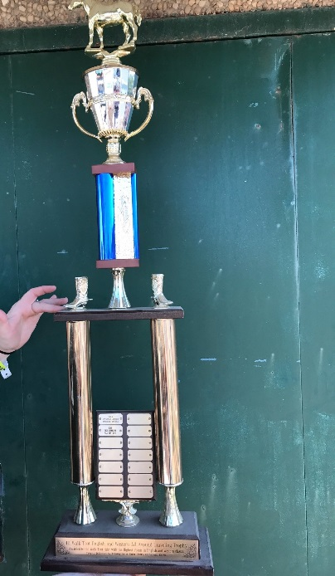

Ted Davies Memorial Rotating Trophy
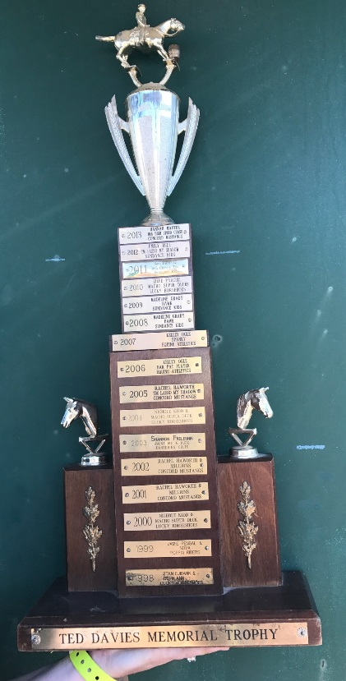

Awarded to the advanced contesting Barrels winner
In loving memory of Ted Davies
Donated by: Davies Family
Established in 1998
Retire________________

Preferred Elegance Memorial Trophy
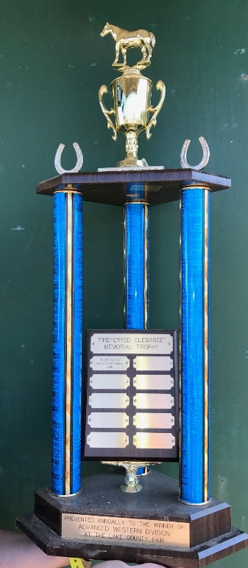
Awarded to the Advanced Western High Point at the Lake County Fair
Established in 2016
In Loving Memory of “Preferred Elegance” (aka Suzie)
Donated by Reins-N-Ribbons 4-h Club
Retired in 10 years to the Roberts Family (2026)

Potti Family Rotating Trophy

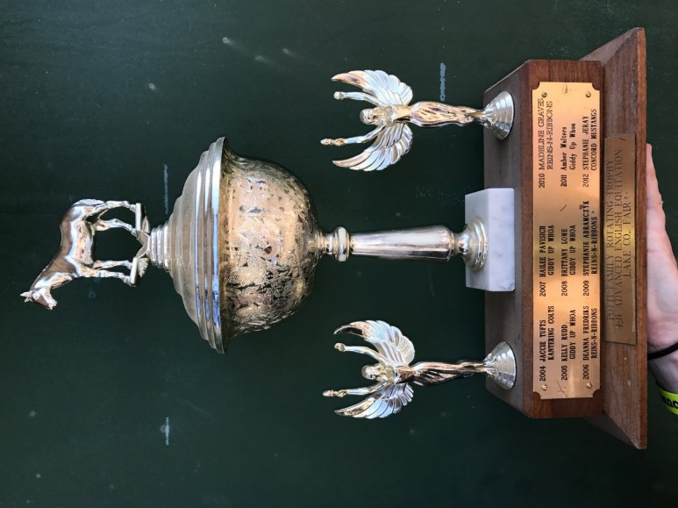
Awarded to the Advanced English Equitation winner at the Lake County Fair
Established 2004
Donated by Lucky Horse Shoes 4-h Club
Dedicated the Potti family for all their hard work and dedication to 4-h
Never to retire. When current trophy runs out of space, the trophy will go to the historical building and a new trophy will be donated.

“Oh My God it’s Sherman” Rotating Trophy
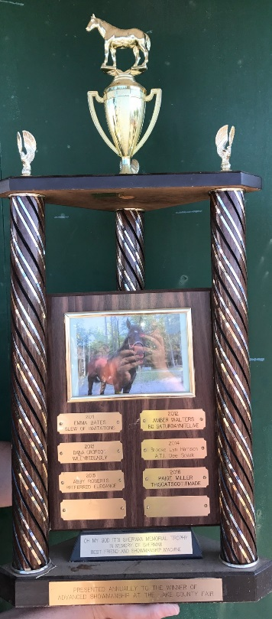

Awarded to the winner of the Advanced English Showmanship class at the Lake County Fair
In loving Memory of “Oh my god it’s Sherman” (aka Sherman )
Donated by Reins-N-Ribbons 4-h club
Established in 2011
Retire to Kenna Covert in 10 years. (2021)

Inspirational Award Rotating Trophy

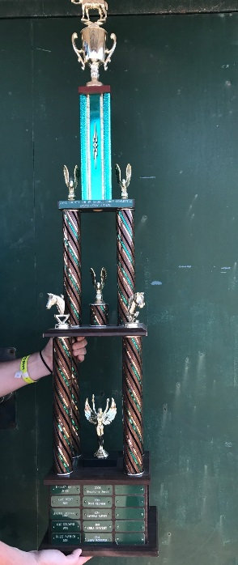
Awarded to the 4-h member who is voted as the most inspirational throughout the show season and fair.
Establish in 2000
Donated by Lake County Saddle Horse
Not going to retire- trophy will either be replaced and/or make repairs

“Black Tie Affair” Rotating Trophy

Awarded to the winner of the advanced road hack at the Lake County Fair
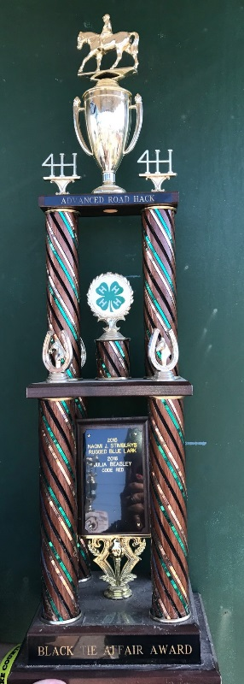
Established in 2015
Donated by the Calhoun Family
In loving Memory of “Black Tie Affair” (aka tux)
Retire to Michaela Calhoun in 10 years (2025)

Crofoot Family Rotating Trophy
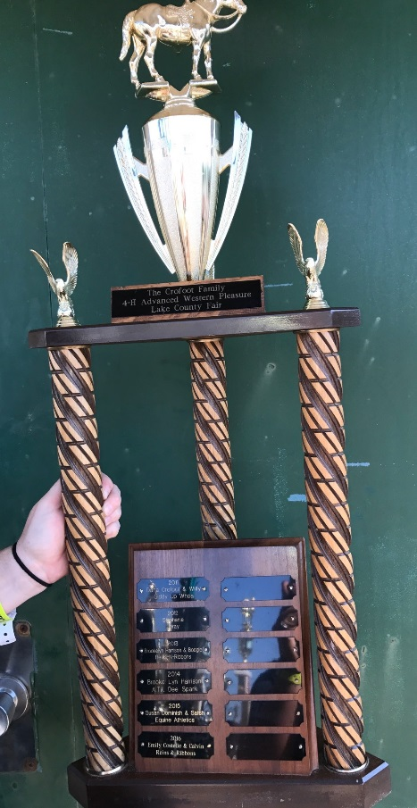

Awarded to the winner of the advanced Western Pleasure class at the Lake County Fair
Established in 2013
Donated by the Crofoot Family
Retire to ______________ in _______

Muddy Boots Novice Barrels traveling Trophy

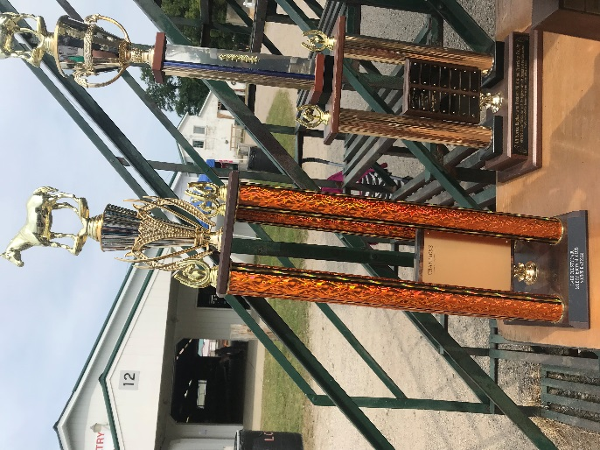
Awarded to the winner of Novice Barrels class during the Lake County Fair.
Donated by Muddy Boots 4-h club
To be retired in ________ to _______

Howard Sutch Award
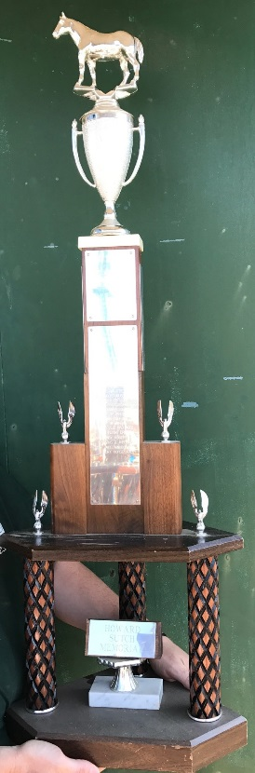

Awarded to the member who matches the criteria for the award (voted by saddle horse)
In loving memory of Howard Sutch
Donated by the Sutch Family
Never to retire; when trophy has no room it will be given to the historical building at the Lake County Fair Grounds.

All around Novice High Point
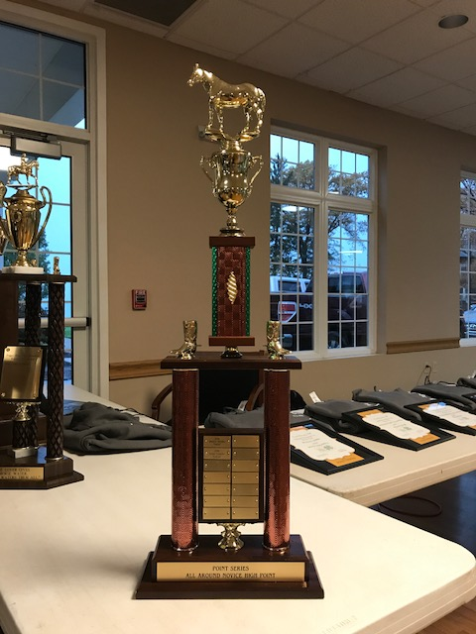
Awarded to the Novice all-around High point at the Points series banquet.
Established__________
Only for Novice riders in the points series
Donated by: __________
Retire ______________________________

M.S. Country Milo Walk/Trot English and Western High Point
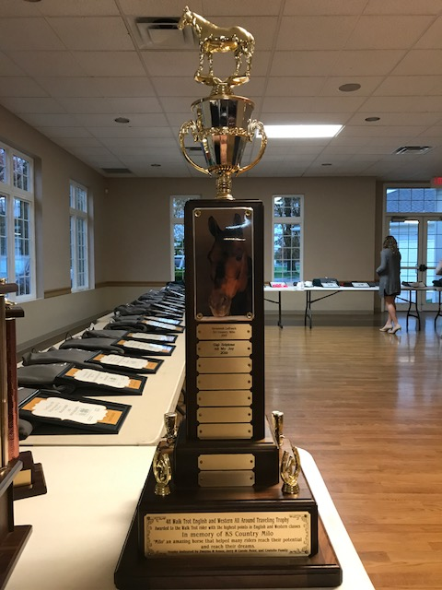
Awarded to the Walk/Trot rider with the most combined points in the English and Western Divisions in the point series. Awarded at the point series banquet.
Participant must be in point series.
In Loving Memory of Milo.
Established in 2015
Donated by the LaRush Family
Retire in 10 years to the LaRush Family (2025)

Kenneth Cuttman Memorial Trophy
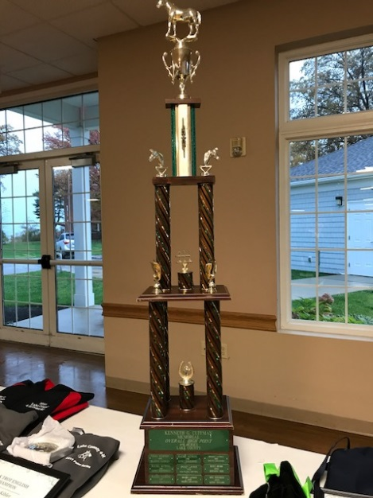

Awarded to the All-Around Advanced at the Point Series banquet.
Participant must be in point series.
In Memory of Kenneth Cuttman
Established______ Donated by: _____________ Never to retire?

Peggy Schroeder Memorial Horseman’s Award
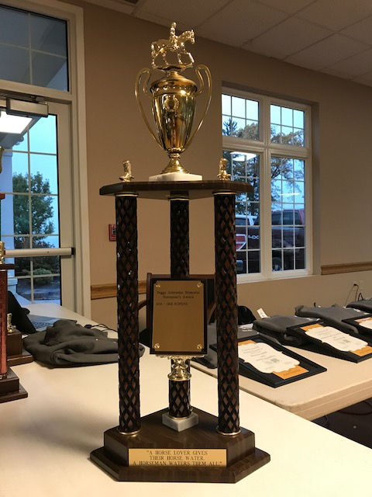

Awarded to a point series participant who exemplifies what horsemanship is.
In Loving memory of Peggy Schroeder
Donated by: Dana Garred and Muddy Boots 4-h
Established: 2016 Retire______________?

Point Series All-Around Walk/Trot High Point

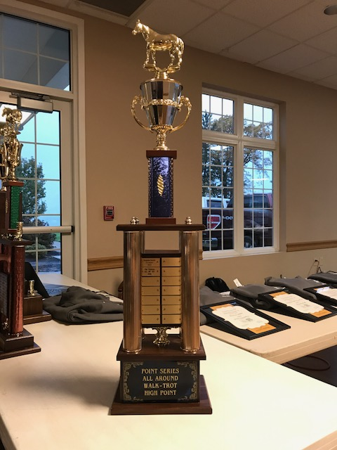
Awarded at the point series banquet to the participant with the most combined points in ALL divisions.
Must be a point series participant.
Established:________
Donated by: ________________
Retire_______?

Novice English and Western All around Traveling Trophy
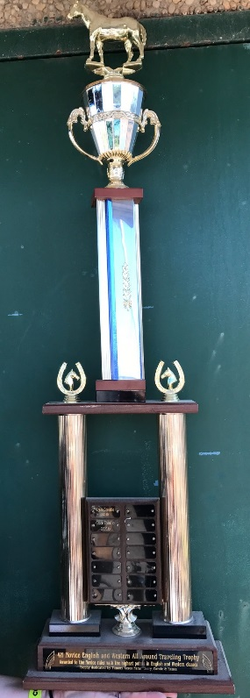

Awarded to the All-Around English and western Novice high point at the Lake County Fair
Donated by Tummy Acers farm, Jerry, Carole and Renee
Establish: 2015
To retire in 2035 to Tummy Acers Farm

The Dorothy Brown-Parker Memorial Trophy
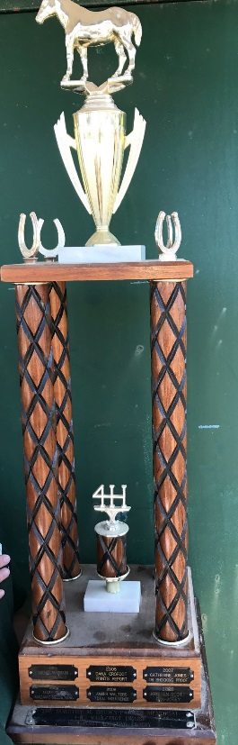

Awarded to the Walk/Trot English High point at the Lake County Fair
In loving memory of Dorothy Brown-Parker
Established in 2003
Donated by: Lucky Horse Shoes 4-h Club
Retire in 20 years to the Historical building (2023)

This Shadow Snazzy Award
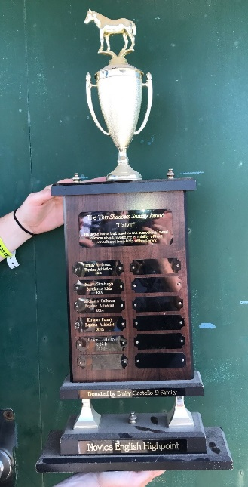

Awarded to the Novice English High point
In honor of “This Shadow Snazzy” (aka Calvin)
Established in 2012
Donated by Emily Costello and Family
Retire in 10 years (2022) to The Costello Family

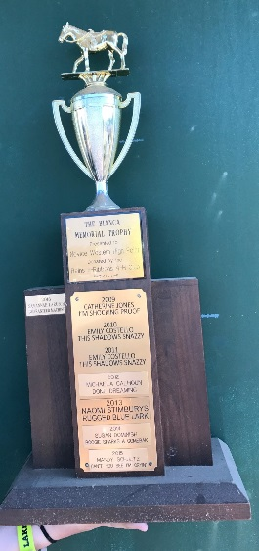
The Bianca Memorial Trophy

Awarded to the Novice Western High Point at the Lake County Fair
In Memory of Bianca
Established in 2009
Donated by Reins-N-Ribbons 4-h Club
Retire in 10 years (2019) to __________________________?

